**DAILY ONLINE ACTIVITIES SUMMARY**

|  |  |  |  |  |  |  |  |  |
| --- | --- | --- | --- | --- | --- | --- | --- | --- |
| **Date:** | **17/06/2020** | | | | | **Name:** | **PRANEETA P HANDRAL** | |
| **Sem & Sec** | **4​th​ SEM. & ‘B’ SEC.** | | | | | **USN:** | **4AL19CS401** | |
| **Online Test Summary** | | | | | | | | |
| **Subject** | | **- -** | | | | | | |
| **Max. Marks** | | **30** | | **Score** | | | **- -** | |
| **Certification Course Summary** | | | | | | | | |
| **Course** | **Blockchain Essentials** | | | | | | | |
| **Certificate Provider** | | | **Cognitive class** | | **Duration** | | | **6 Hrs.** |
| **Coding Challenges** | | | | | | | | |
| **Problem Statement:** Write a C Program to Count numbers that don’t contain 3.  **Given a number n, write a function that returns count of numbers from 1 to n that don’t contain digit 3 in their decimal representation.**  **Examples:**  **Input: n = 10**  **Output: 9**  **Here input is 10 means the numbers within 10 are 1,2,3,4,5,6,7,8,9,10 in this series 3 occurs only 1 times so answer is 9**  **More examples**  **Input: n = 45**  **Output: 31**  **// Numbers 3, 13, 23, 30, 31, 32, 33, 34,**  **// 35, 36, 37, 38, 39, 43 contain digit 3.**  **Input: n = 578**  **Output: 385** | | | | | | | | |
| **Status:** **Executed.** | | | | | | | | |
| **Uploaded the report in Github** | | | | | **Yes** | | | |
| **If yes Repository name** | | | | | **LockdownCoding**  <https://github.com/praneetahandral/lockdowncoding> | | | |
| **Uploaded the report in slack** | | | | | **Yes** | | | |

**Online Test Summary:** No internals conducted.

**Online Certification course Summary​:** I have taken my Online Certification Course in **Cognitive class**  the course which I have opted is **Blockchain Essentials**. Course contains videos, tutorials, assessments and quiz. Today I have gone **Example Blockchain Networks** and An overview of key IBM Blockchain solutions.

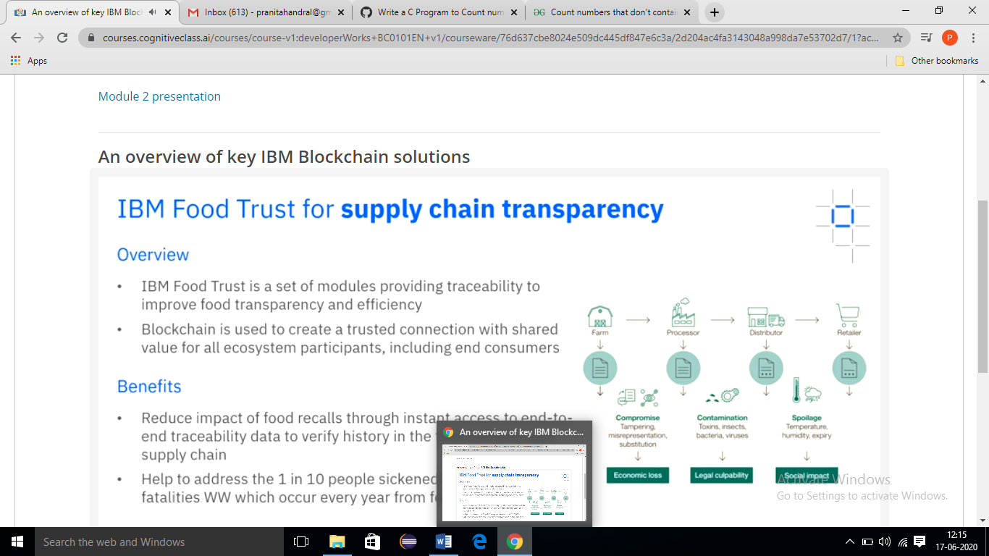

**Online Coding Summary​:** Today I received one programs from prof. Shilpa CSE Dept.. I have written one program and uploaded it to my Github repository. This is my repository snapshot. I have uploaded the frequency program.

